主标题：5G rugged tablet
副标题：Y100 5G rugged tablet
Key features:
CPU:1*A76@2.7GHz+3*A76@2.3GHz+4*A55@2.1GHz，Android 13
Memory :4G+128G Optional: 8G+128G，8G+256G
10.1-inch resolution 800 * 1280 optional: 1200X1920
NPU 8 TOPS AI Computing Power
5G NR, LTE-FDD, LTE-TDD, WCDMA, GSM
WLAN: 2.4/5G, 802.11a/b/g/n/ac, BT5.0
GNSS: GPS/GLONASS/Galileo/Beidou, L1
Barcode, QR code scanning

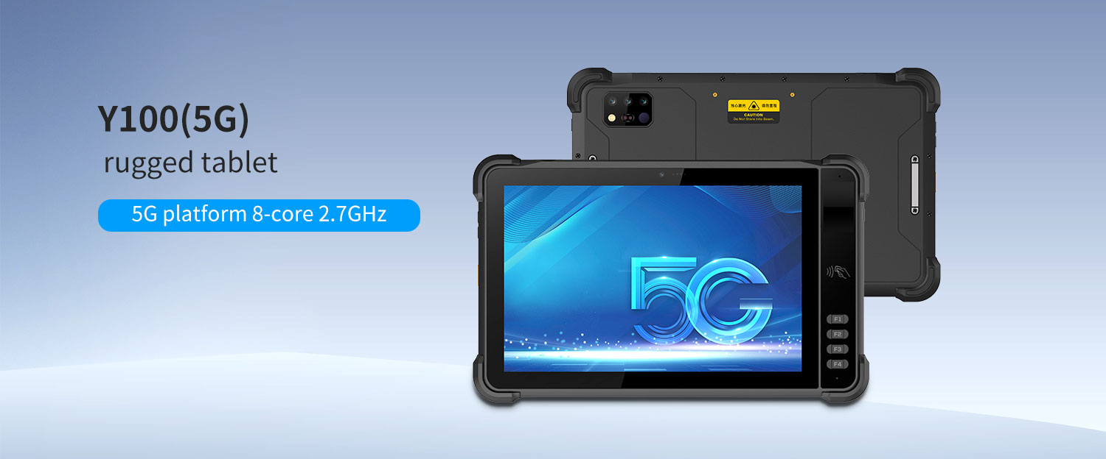
• 5G rugged tablet Equipped with high-performance 5G platform 8-core 2.7GHz processor, Android 13 operating system, 4G+128G standard memory, running faster and more stable
• IP67 dustproof and waterproof; The body is made of high-strength industrial grade materials, which are sturdy and durable.
• 10.1-inch high-definition display screen, supporting multi touch, glove touch, water operation, and passive pen signature
• Built in 10000mAh large capacity battery, with ultra long battery life, can meet the needs of long-term outdoor work
• Optional functions: barcode scanning, QR code scanning, NFC, RFID reader, biometric fingerprint recognition, night vision camera, infrared thermal imaging and other functional modules.

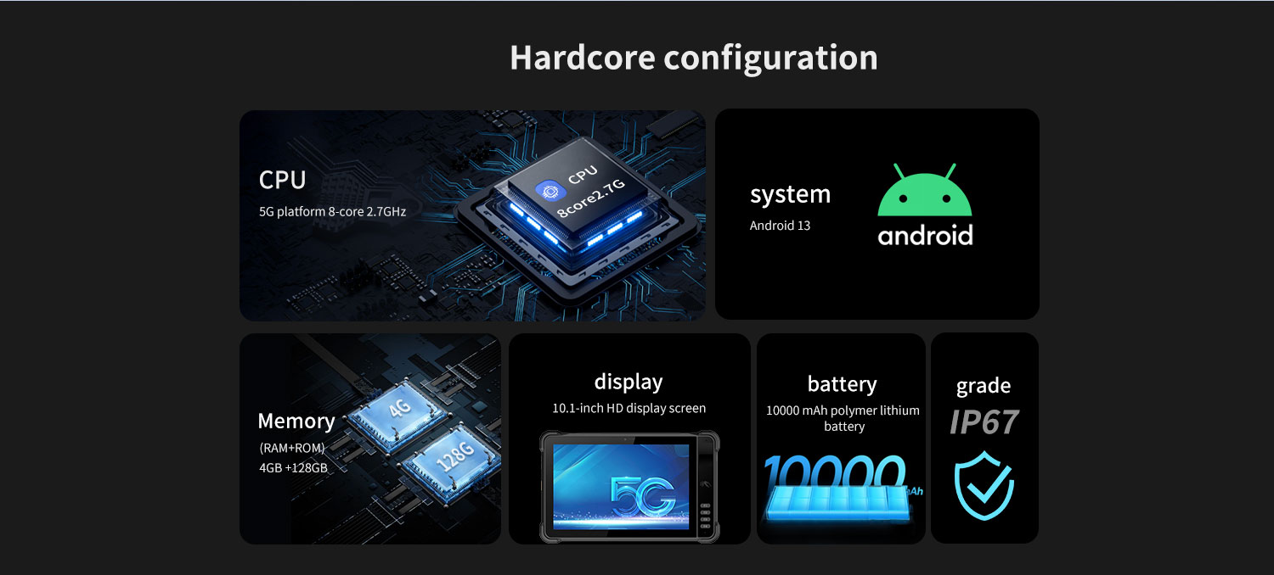
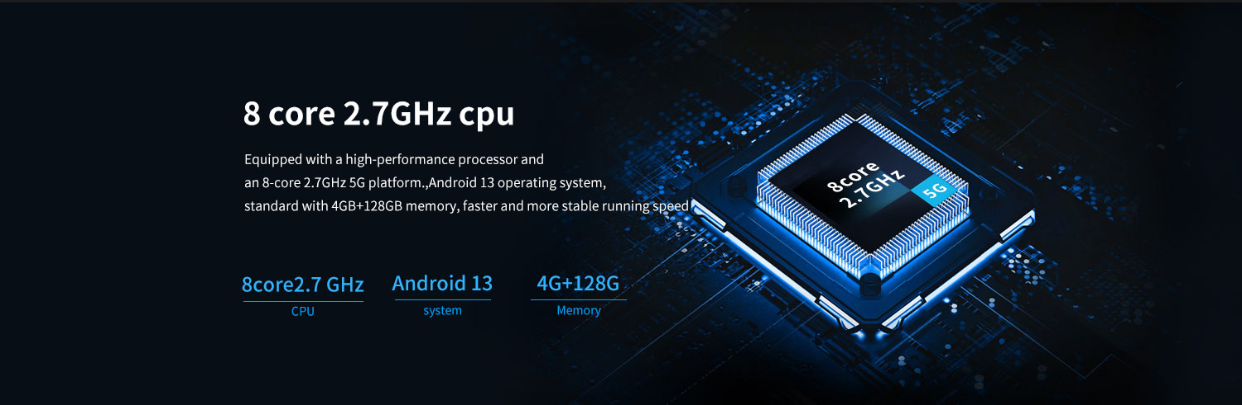
8-core 2.7GHz processor
Equipped with a high-performance processor and an 8-core 2.7GHz 5G platform. Android 13 operating system, standard 4GB+128GB memory, faster and more stable running speed
﻿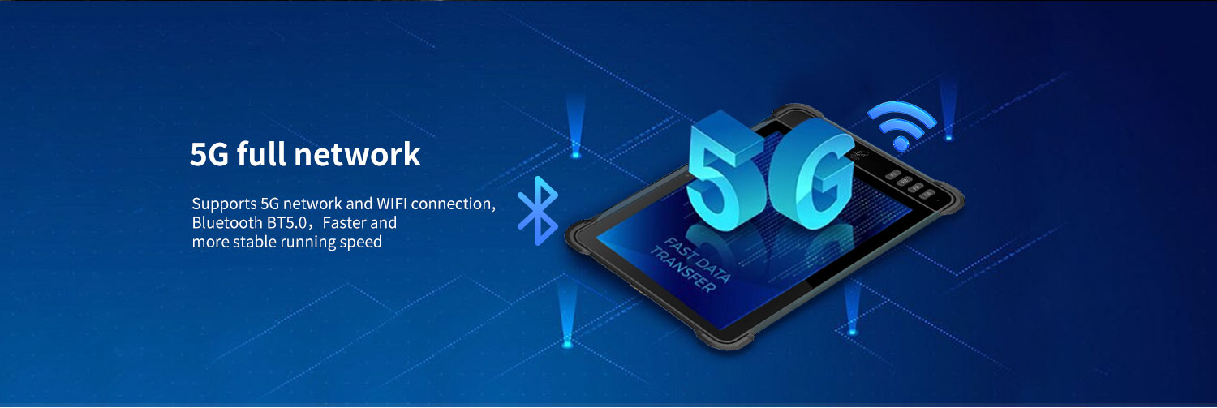
5G full network
Supports 5G network and WlFl connection,Bluetooth BT5.0，Faster andmore stable running speed

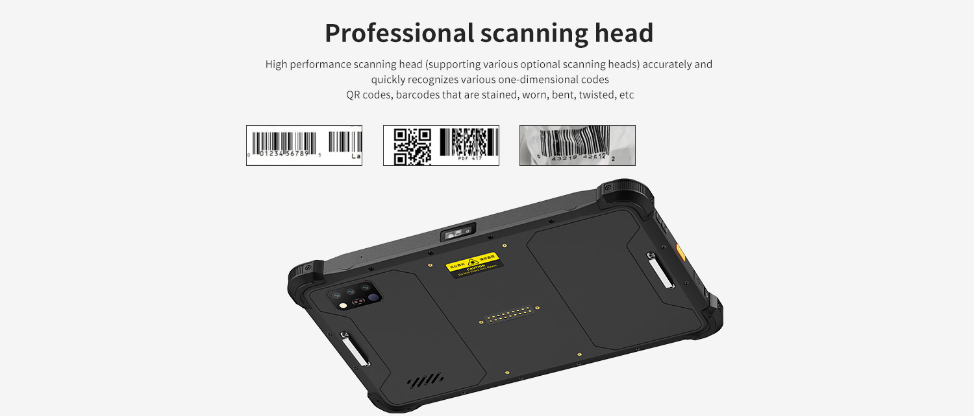
Barcode and QR code scanning (optional)
The 5G rugged tablet supports the optional professional scanning engine, which can accurately and quickly recognize various barcodes, QR codes, as well as colored, worn, bent, twisted and other barcodes﻿
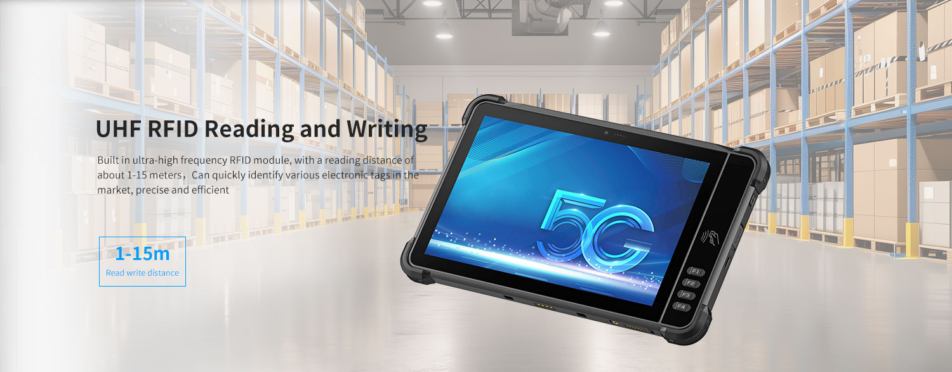
UHF RFID reader/writer (Optional)
Built-in Impinj E710 chip UHF RFID module, RFID tag reading range of approximately 1-15 meters, excellent group reading performance. It can efficiently and quickly identify popular electronic tags on the market with accuracy.
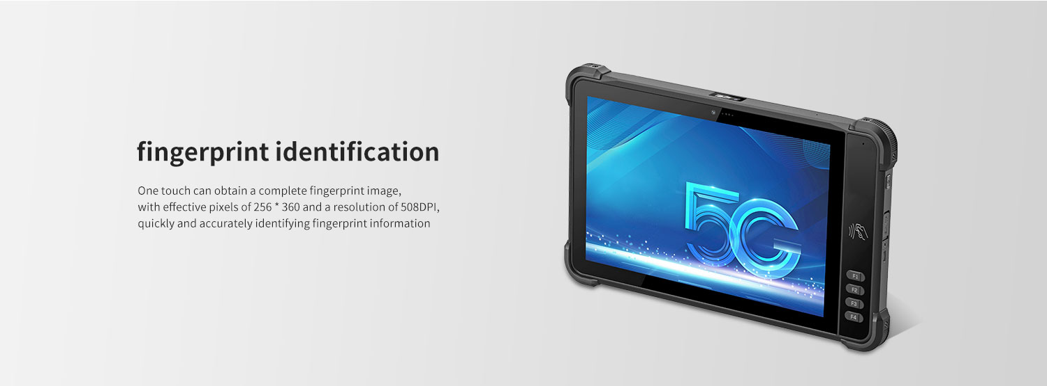
fingerprint identification (Optional)
One touch can obtain a complete fingerprint image,with effective pixels of 256 *360 and a resolution of 508DPlquickly and accurately identifyingfingerprint information
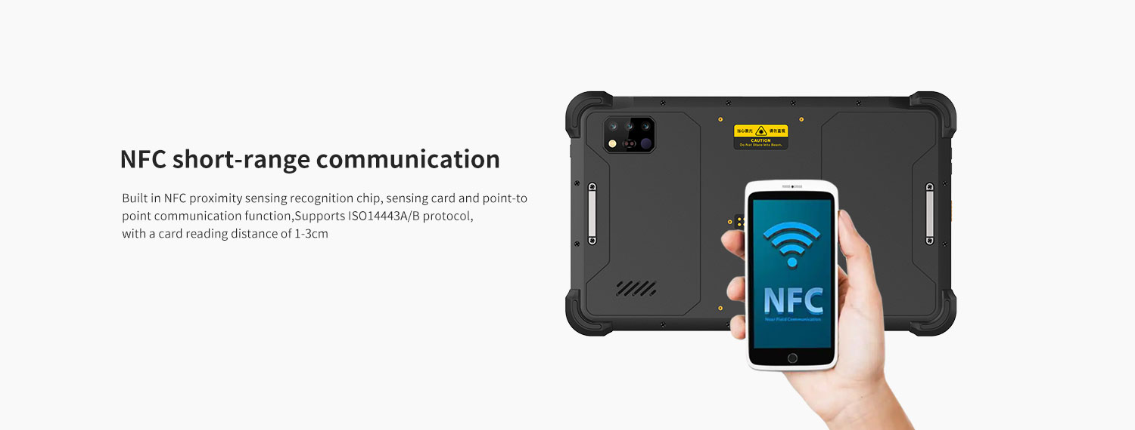
NFC short-range communication
Built in NFC proximity sensing recognition chip, sensing card and point-topoint communication function,Supports iS014443A/B protocol,with a card reading distance of 1-3cm
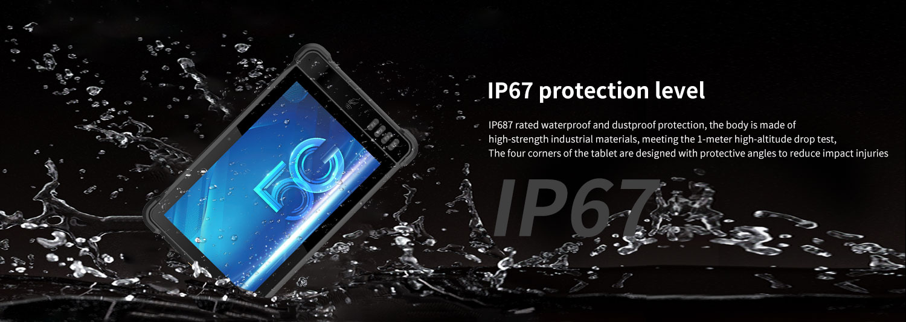
Protection level
IP67 dustproof and waterproof; The body is made of high-strength industrial materials, which are sturdy and durable, and can meet the requirements of a 1-meter high-altitude drop test. The four corners of the tablet are designed with protective angles, effectively reducing impact injuries.

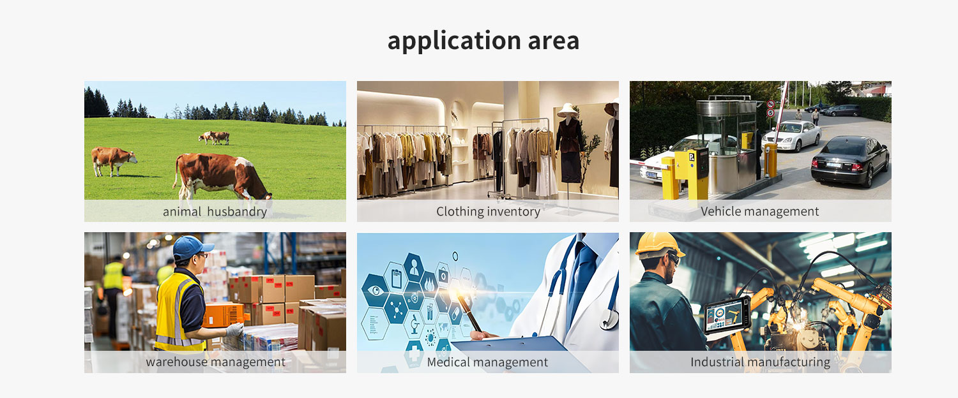
Provide ODM and OEM customized services
• We work closely with our partners and can provide various one-stop customized solutions.
• Appearance customization: supports customization of product nameplates, product packaging, and promotional materials.
• Hardware customization: Supports customization of functional modules and optional hardware functions.
• Software customization: supports customization of boot interface, boot program, kernel clipping, and API interface.
• Technical support: Provide SDK development kits and application software development technical services.

Y100 5G rugged tablet is a multifunctional rugged tablet developed independently by LQYCIT. 10.1-inch high-definition large screen, equipped with high-performance processor; 5G communication 8-core 2.7GHz, WIFI, GPS, BT. Android 13 operating system, standard memory: 4GB+128GB; Optional: 6G+128G, 8G+128G, 8G+256G. Built in 10000mAh high-capacity battery with IP67 protection level. Supporting optional options: barcode, QR code scanning, NFC， Ultra high frequency RFID module, fingerprint module, RTK high-precision positioning module, night vision camera, thermal imager, UWB ranging positioning module and other modules. Strong industry adaptability, widely used in livestock breeding management, bank material management, military equipment material management, clothing inventory, warehouse management, smart factories, medical, municipal and other application fields. Help users quickly achieve information management and improve enterprise operational efficiency.

HARDWARE CUSTOMIZATION
1: Nameplate Logo Customization
2:Packaging Custom Design
﻿
SOFTWARE CUSTOMIZATION
1:Boot Screen Customization
2:System Function Hiding
3:Built-in Customer App
4:Customer App Auto-launch
5:Platform Software Integration
6:Fixed MAC Address
7:Download Prohibition
﻿8:USB Disablement
﻿9:APP Installation and Uninstallation Control
10:Pre-installed APK
﻿11:Camera Control
12:Provide System Signing Files

frequently asked questions
Q: Are you the original manufacturer?

A: Yes, we are the original manufacturer. We have our own brand LQYCIT. All of our products have complete patented ID/MD designs, hardware and software, molds, and assembly are all completed by our own team.

Q: Can you pre install our software?

A: Yes, we can pre install your software.

Q: What is the minimum order quantity?

A: We accept standard product orders starting from one unit. If necessary, we can even customize your logo. For OEM, our sales team will review the detailed requirements and confirm the minimum order quantity.

Q: Can we get free samples?

A: Sorry, we usually do not provide free samples. If the customer confirms the specifications and pricing, they can first order samples for testing and evaluation.

Q: How to place an order and make payment?

A: We accept wire transfers (bank transfers), Alibaba online payments, and Western Union remittances.

Q: What is the warranty period for your products?

A: We offer a 12-month warranty after shipment.

Q: How long is the delivery time?

A: The production delivery cycle is about 3-10 days, depending on the requirements. The delivery time through DHL/UPS/FedEx/TNT is approximately 3-5 working days. For some remote areas, the transportation time may be longer.

Q: How to fix equipment problems?

A: We will provide online technical support to solve problems. For hardware issues, we can ship parts or components for customers to install (if they have technicians), or we can ship them back to us for repairs.

